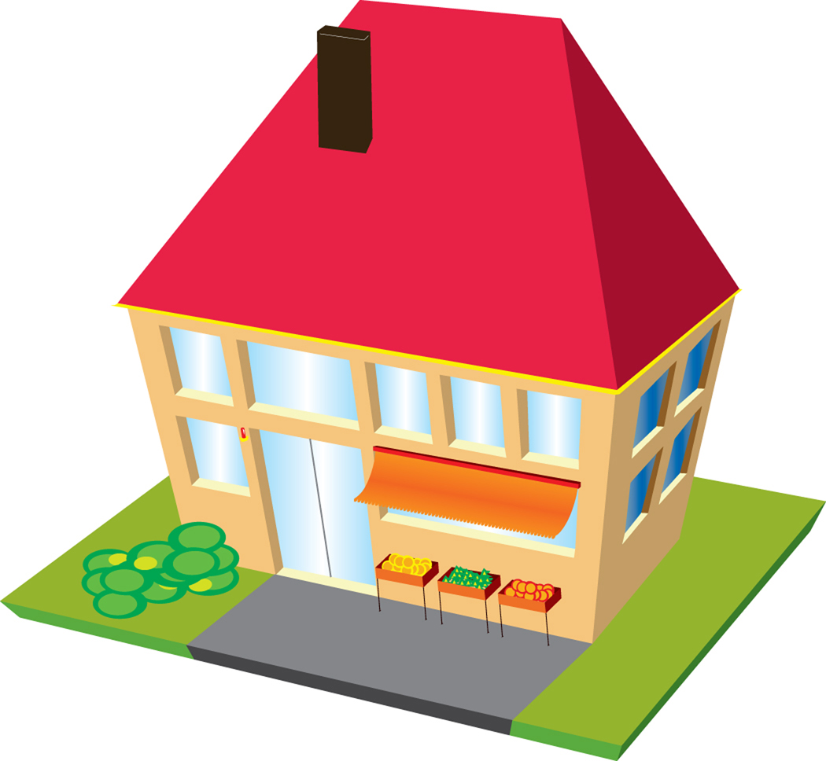
My Safety Plan

My name is ____ ______________________

If there are angry actions or words in my house – I can’t stop it

This is what I can do:

- GET OUT OF THE WAY.

- Find a safe place. In my house this is ___________________

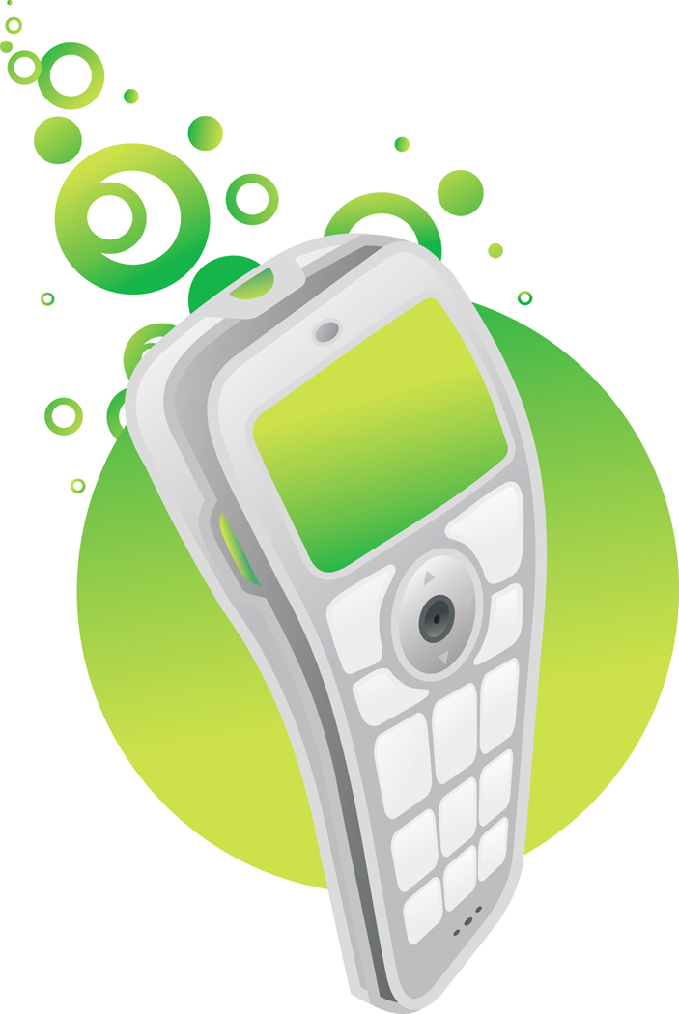
- If it is SAFE, phone the police

- Dial 999(if it’s not safe to talk, press 55 and stay on the phone

- say my name ___________________________

- say my home address ___________________________

___________________________

- say what is happening ___________________________

___________________________

- I can also get help from ___________________________

- Later I can talk to ________________ about what happened.

- If I am hurt I will tell ______________________________

- It is ok to feel ______________________________
- The people who know about this plan are:

Me

Family

Others

- I’ll keep this plan in _____________________________

Signed ____________________ Child date ________

